**MindCare: AI-Powered Mental Health Chatbot**

1. **Problem Statement**

Mental health support is often hindered by stigma, lack of engagement, and high dropout rates. Many individuals struggle to stay consistent with therapy, leading to ineffective outcomes and worsening mental health.

1. **Introduction**

Therapy adherence is often low due to stigma and lack of engagement. TherapyBuddy is an AI-powered chatbot designed to enhance therapy adherence, reduce dropouts, and improve mental well-being. By offering personalized support through engaging features like daily challenges, gamified activities, and tailored conversations, TherapyBuddy keeps users motivated and involved in their mental health journey. The goal is to make therapy more accessible, consistent, and effective for individuals struggling with anxiety, depression, and stress.

1. **Our Solution**

TherapyBuddy is a mental health support platform that combines AI and gamification to enhance therapy adherence and user engagement. Our solution includes:

* **AI Chatbot (TherapyBuddy):** Personalized, human-like conversations to provide emotional support.
* **Daily Challenges:** Interactive mental health tasks to encourage consistent participation.
* **Gamified Relaxing Activities:** Fun activities to reduce stress and promote self-care.
* **Gratitude Journal:** A space for users to reflect on positive experiences.
* **Streak Tracking:** Motivates users to stay consistent by rewarding regular participation.

Through these features, TherapyBuddy helps users manage stress, reduce loneliness, and stay committed to their mental well-being.

1. **Landing Page**

The MindCare landing page is the gateway to personalized mental health support, offering a clean and intuitive interface with:

* **User Authentication:** Easy sign-up and login for secure, personalized access.
* **Navigation:** Quick access to TherapyBuddy, guided activities, and daily challenges.
* **Engaging UI:** A user-friendly, visually appealing design for better user experience.
* **Dashboard Access:** Track progress, manage streaks, and access support easily.

[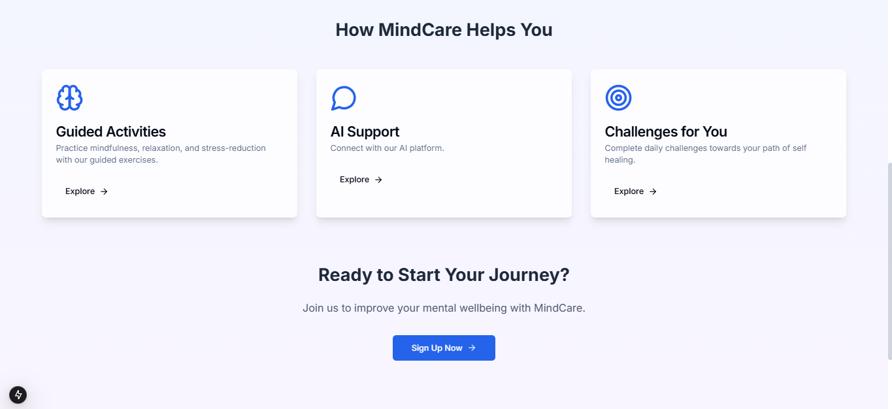](https://drive.google.com/file/d/1HJVOiwwf2g-mK9o8JTMsPgykhe4ef62u/view?usp=drive_link)

1. **Login/ SignUp**

Secure and seamless user authentication ensures personalized experiences and data privacy:

* **User-Friendly Access:** Simple login and sign-up process for new and returning users.
* **Secure Authentication:** Protects user data while providing a personalized journey.
* **Personalized Dashboard:** Access tailored mental health resources post-login.

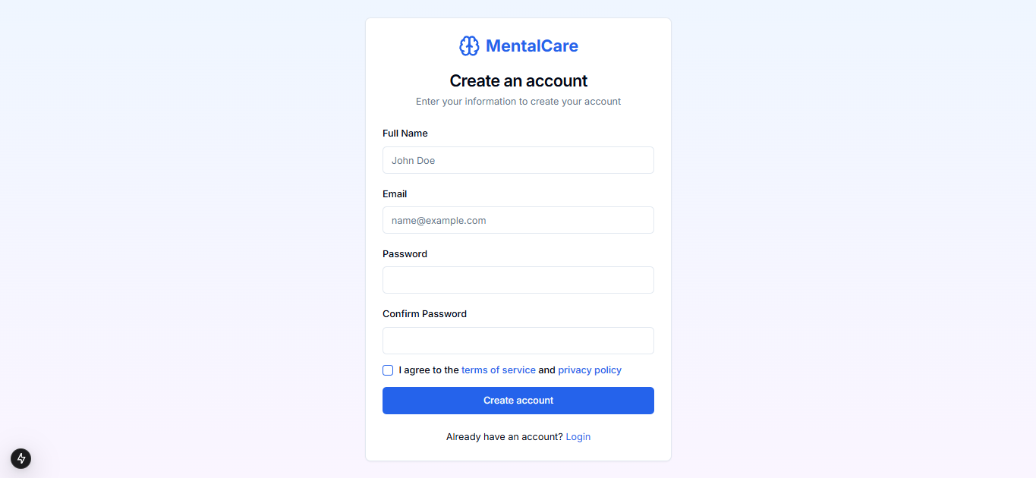

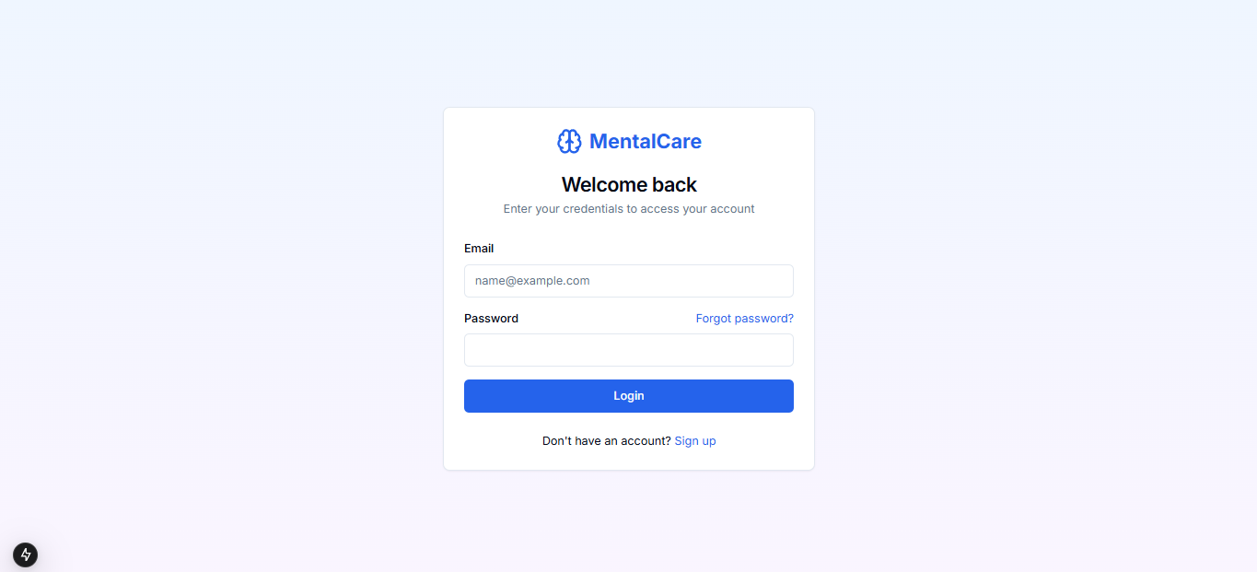

1. **Dashboard**

A centralized hub for tracking progress and accessing key features:

* **User Overview:** Displays mental health progress and active streaks.
* **Quick Navigation:** Easy access to TherapyBuddy, activities, and challenges.
* **Help & Support:** Instant assistance for users in need of guidance.

[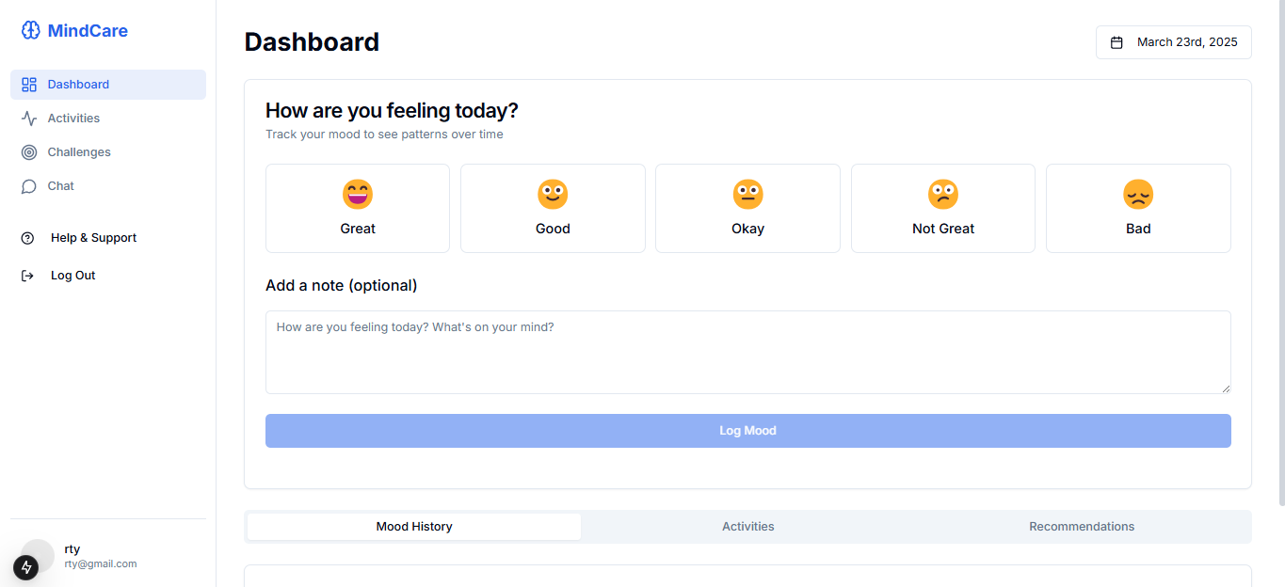](https://drive.google.com/file/d/156MI-5Phmg0yQ4-lq5ggSPkG6xeRobGL/view?usp=drive_link)

1. **Self-Care Activities**

Gamified, relaxing activities designed to promote self-healing and stress relief:

* **Engaging Tasks:** Fun, interactive exercises to reduce anxiety and stress.
* **Personal Growth:** Encourages reflection and positive habit formation.
* **Gamification:** Rewards users for completing activities, enhancing engagement.

[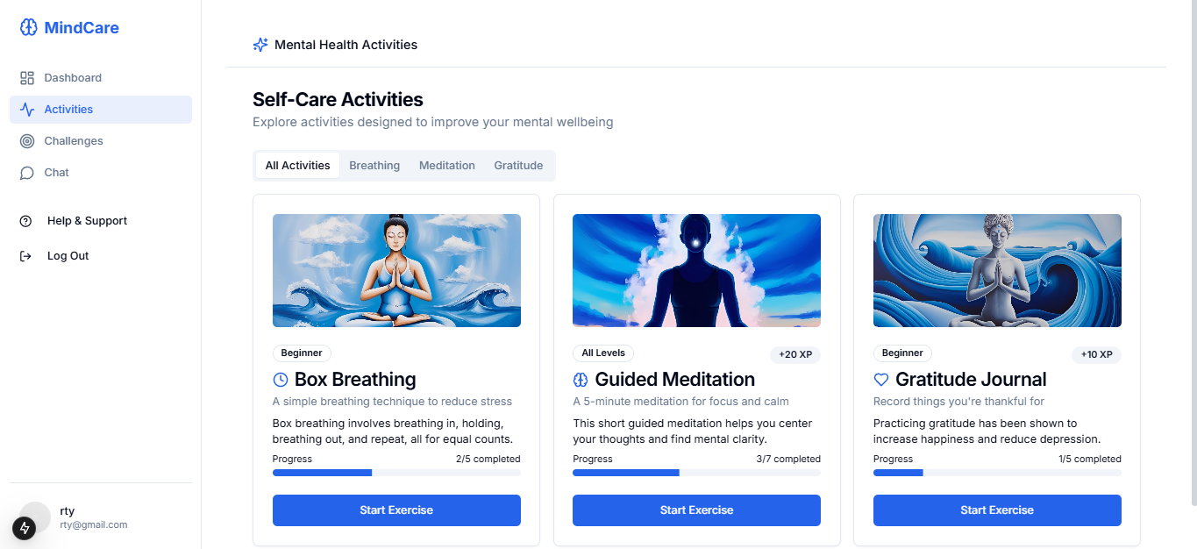](https://drive.google.com/file/d/1BKUATSVtLuhwj8TVMl4cbjNiHBqEOnDk/view?usp=drive_link)

1. **Daily Challenges**

Interactive tasks to keep users motivated and improve therapy adherence:

* **Mental Health Tasks:** Daily exercises promoting mindfulness and emotional well-being.
* **Streak Tracking:** Encourages consistency through rewards and progress monitoring.
* **User Engagement:** Increases long-term involvement with therapy practices.

[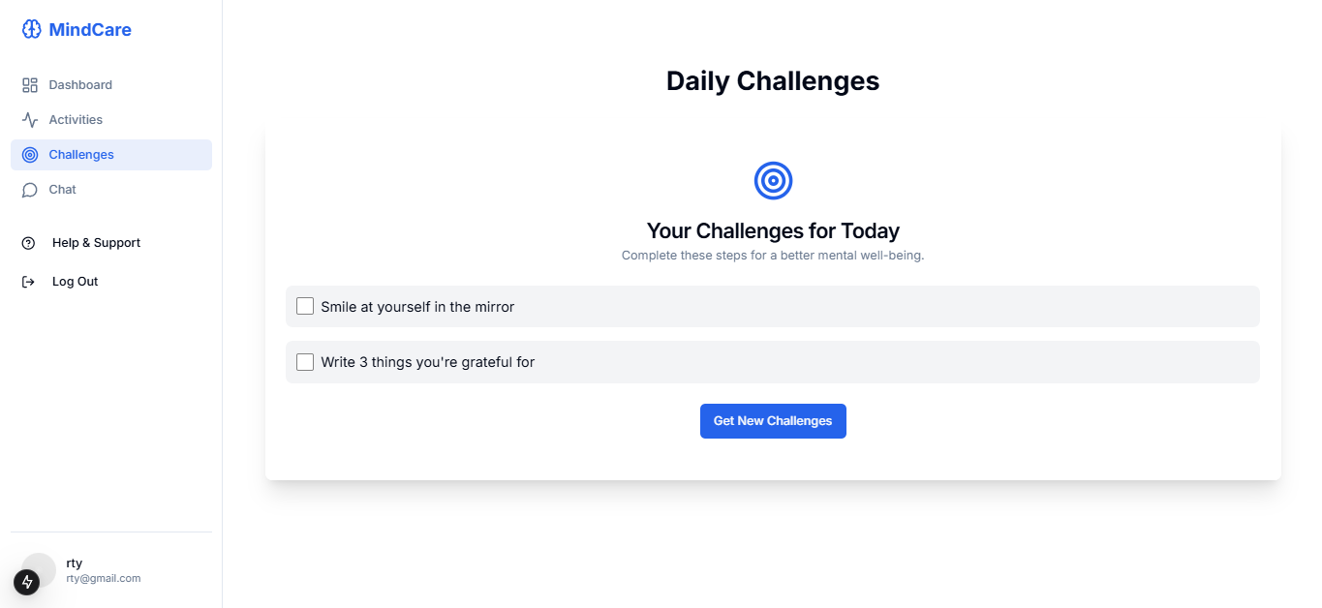](https://drive.google.com/file/d/1tA4ozrMPKrB_IsG3kEtsqQyvaUnOqDc7/view?usp=drive_link)

1. **Chat with AI Companion: TherapyBuddy**

A supportive, human-like AI chatbot offering personalized mental health assistance:

* **Personalized Conversations:** Tailored responses for emotional support.
* **24/7 Availability:** Always accessible for users seeking immediate help.
* **Emotional Connection:** Simulates a friend-like interaction to reduce loneliness.

[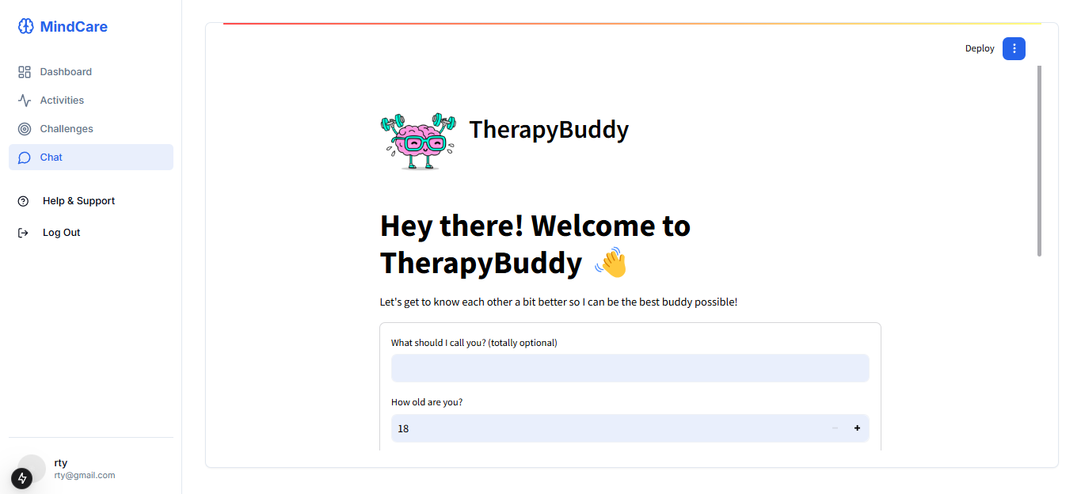](https://drive.google.com/file/d/1fHcK8VG2W_2B8UZSbS88Mb6r-ONA6veM/view?usp=drive_link)

1. **Help & Support**

A dedicated section to provide users with assistance and resources:

* **Instant Help:** Provides quick solutions for common issues.
* **User Guidance:** Step-by-step instructions for navigating the platform.
* **Mental Health Resources:** Links to professional support and external resources.

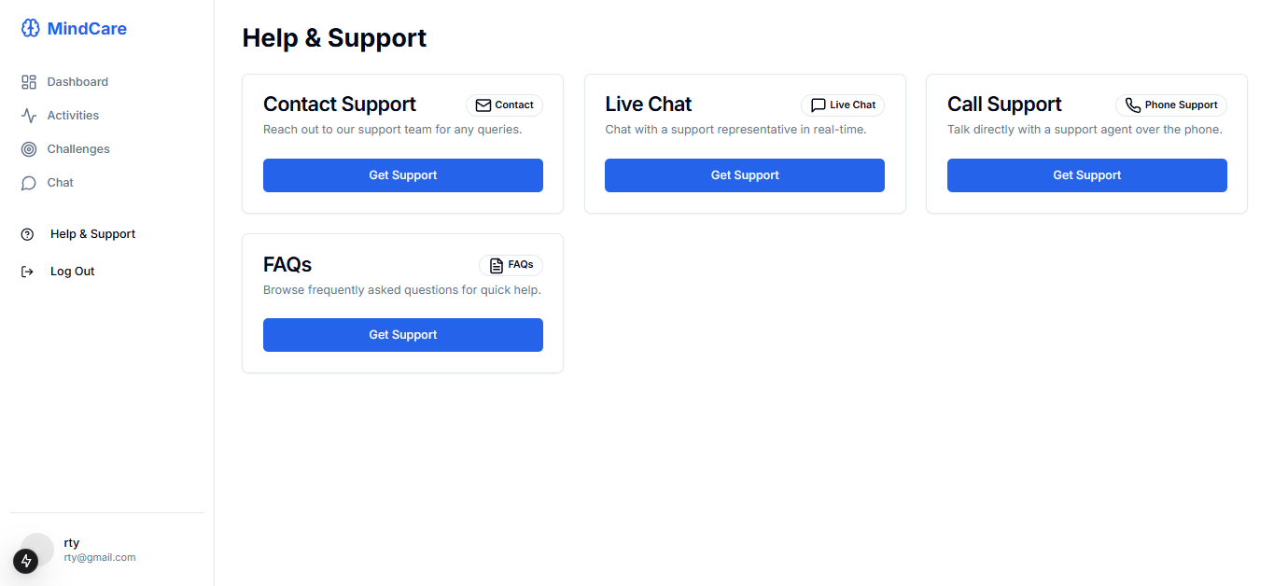

1. **Conclusion**

TherapyBuddy revolutionizes mental health support through AI and gamification, ensuring better therapy adherence and user engagement:

* **Enhanced Therapy Adherence:** Keeps users consistent with personalized support.
* **Innovative Features:** Combines AI with gamified activities for a unique experience.
* **Scalability:** Designed to grow and support diverse mental health needs.

**Empowering users to take charge of their mental well-being—one conversation at a time.**